

Asia Pacific College

School of Computing and Information Technology

3 Humabon Place, Magallanes Vlg., Makati City

Inventory Management System

By:

Caguioa, Armersson

Gregorio, Felix

Romblon, Daveson

Mendoza, Karlo

BSIT-MI142

Prof. Manuel Sebastian Sanchez

CSPROJ Instructor

December 12, 2016

Contents

I. Introduction 3

Project Context 3

Client Profile 3

Client’s Mission and Objectives 3

Purpose and Description 4

Project Objectives 4

Scope and Limitation 4

II. Review of Related Literature/System 6

III. Technical Background 7

Software Environment 7

Web-based Server System Requirements 7

Notes: 8

IV. Methodology, Results and Discussion 9

Agile Methodology 9

Results and Discussion 9

V. Conclusions and Recommendations 13

# Introduction

## Project Context

SMC is one of the top schools in the Philippines offering Basic Education and College. They are supervised by Southville International School and Colleges, a school with international character with international accreditation from the Western Association of Schools and Colleges.

Inventory management software is a computer-based system for tracking inventory levels, orders, sales and deliveries. Companies use inventory management software to avoid product overstock and outages. It is a tool for organizing inventory data that before was generally stored in hard-copy form or in spreadsheets.

## Client Profile

South Mansfield College has recently assigned the Inventory System of their shop to be developed by Team AFKD, information technology students of Asia Pacific College. The project will focus on building a web-based inventory system which provides a simplified and more user-friendly approach for the existing and potential users. The shop administrator required the team to include an ordering which handles customer orders and reporting module to generate excel reports for the shop’s inventory system.

## Client’s Mission and Objectives

South Mansfield Inventory System will establish in Southmansfield College through a web-based platform that will mainly suffice inventory needs of SMC. The setup of the project will be using the school’s main website that has an order form to utilize the system. The project will provide automation of manual works that causes delays in transactions which will increase their productivity and the students waiting time will dramatically decrease. The school management should approve the project for the project to be deployed and function.

## Purpose and Description

The purpose of this project is to create a web-based inventory system that features:

1. Asset tracking: When a product is in the store, it can be tracked via item number.
2. Service management: To track sales and purchases. This way, they can see the in and out of items.
3. Inventory optimization: A fully automated demand forecasting and inventory optimization system to attain key inventory optimization metrics such as: Reorder point, Order quantity, Lead demand, Stock cover, and others.

## Project Objectives

The target of this project is to take out heaps of manual work and mistakes that could be exorbitant for the business and alleviates the operational burden by automating and streamlining processes and also have a user friendly system that easily to manage.

## Scope and Limitation

The project focuses only on the inventory system of South Mansfield College. The main requirement needed for this project are the three modules: ordering, reporting, and inventory that would follow the business rules stated by the client. The project will try to accomplish atleast 80% of the functionalities required.

The scopes of the proposed system are sales, inventory, and reporting modules. The sales module covers the selling of items. Inventory module keeps track of the assets and purchases. Reporting module covers the summary reports on inventory, sales and purchase.

# Review of Related Literature/System

Whether you are tracking inventory used to perform a service or sold to customers, using an inventory system provides staff accountability and minimizes inventory stockouts and shrinkage.

Clearly Inventory is an online inventory system that offers Low-Cost Inventory Tracking that features total control of user access, data management, data filters for easy search, and display inventory and sales reports.

TradeGecko manage all your sales, stock, accounting, shipping and customer data from a single place. Inventory control to improve tracking and control over inventory activities and stock movements. Inventory optimization to anticipate demand and receive reorder alerts in time so you'll never experience stockouts again.

Megaventory is web-based inventory, order management, CRM and reporting system for small to medium businesses with multiple locations. Add multiple users with variable permissions, track inventory levels, prepare sales and purchase orders, sales quotes, handle inbound and outbound goods and regain overall the control of your company. Rapid Inventory, powered by Accucode, is a cloud- based inventory management system that seamlessly integrates with QuickBooks Pro, Premier and Enterprise. Rapid Inventory will make it easy to track your inventory across multiple warehouses and locations, lot numbers, expiration dates and hold reasons. With our QuickBooks inventory management software, you will process more transactions in less time and eliminate costly errors, improving your inventory accuracy and lowering your costs.

# Technical Background

## Software Environment

**1. Programming Languages**

* + PHP
  + CSS
  + HTML
  + Bootstrap
  + Javascript

**2. Specific Software**

* + Yii2 Template
  + Sublime Text 3
  + XAMPP Control Panel

**3. Web Server Application**

* + PHPMyadmin

## Web-based Server System Requirements

1. **Minimum Hardware Requirements**
   * **Processor:** Dual Core CPU 2.0GHz
   * **Instruction Set:** 64-bit
   * **RAM:** 4GB
   * **HDD:** 250GB
2. **Operating System**
   * Windows 7 SP1 (32-bit/64-bit); OR
   * Microsoft Windows Server 2008 SP2 (32-bit); OR
   * Microsoft Windows Server 2012 (64-bit)
3. **Database Requirements**
   * XAMPP Control Panel
4. **Server**
   * Apache

## Notes:

* **The system must be accessible by desktop computers and laptops (connected through LAN) within the campus.**
* **The system will utilize Apache as its Web-Based Server System.**
* **The system must be able to retrieve, store and view data.**

# Methodology, Results and Discussion

## Agile Methodology

This is the methodology used in developing the Southmansfield Inventory System. The project team uses the Agile Development Methodology to assess the direction of a project throughout the development lifecycle. According to the research, the use of Agile Methodology will guarantee the quality of the system throughout the development life cycle. The project team could achieve this through regular cadences of work, known as sprints or iterations, at the end of which the project team will be able to present a potentially working system. Small incremental releases will be visible to the project team to identify any issues early and make it easier to respond to change. The clear visibility in agile development helps both client and project team to ensure that any necessary decisions can be taken at the earliest possible opportunity. The team goes through a series of iterations, analyzing, designing, developing and testing each feature in turn within the iterations. Each feature is taken from start to finish with an iteration, with the software being tested at the end of each iteration. Based on the Project Base Learning Track of the project members, there would be at least 3 iterations before the proposed system will be deployed and integrated in Southnmansfield Inventory System. Each iteration covers 3 and a half months including the Alpha and Beta Testing.

## Results and Discussion

The following are screenshot of the system that would suffice the operational processes that the shop follows.

**Login page**

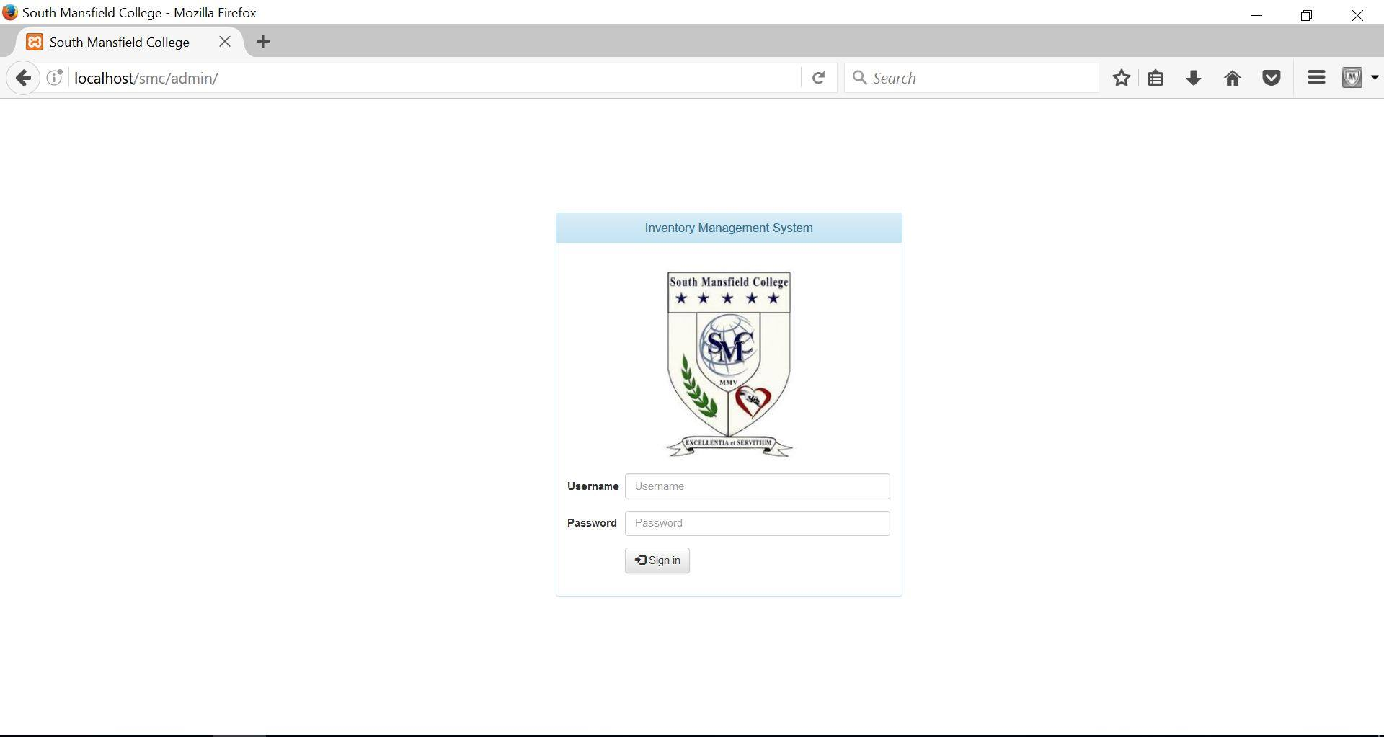

**Admin Dashboard  
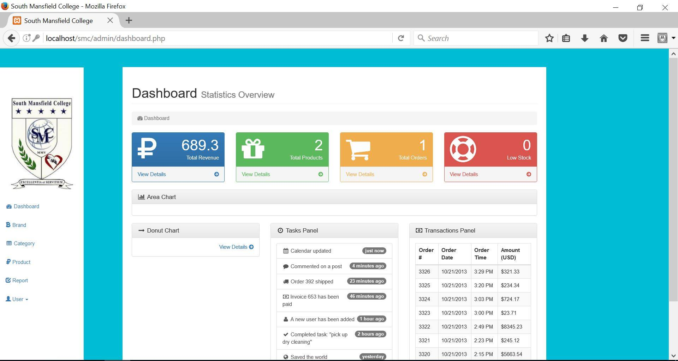**

**Management of Categories**

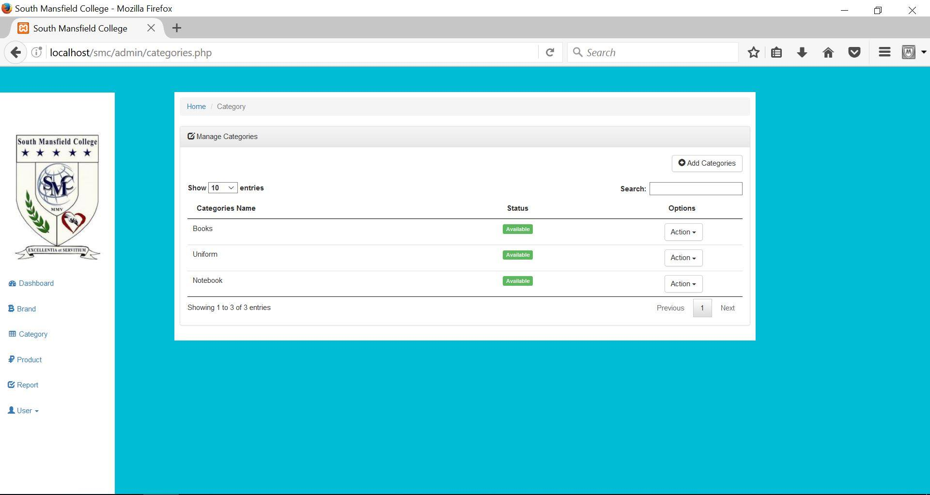

**Management of Product**

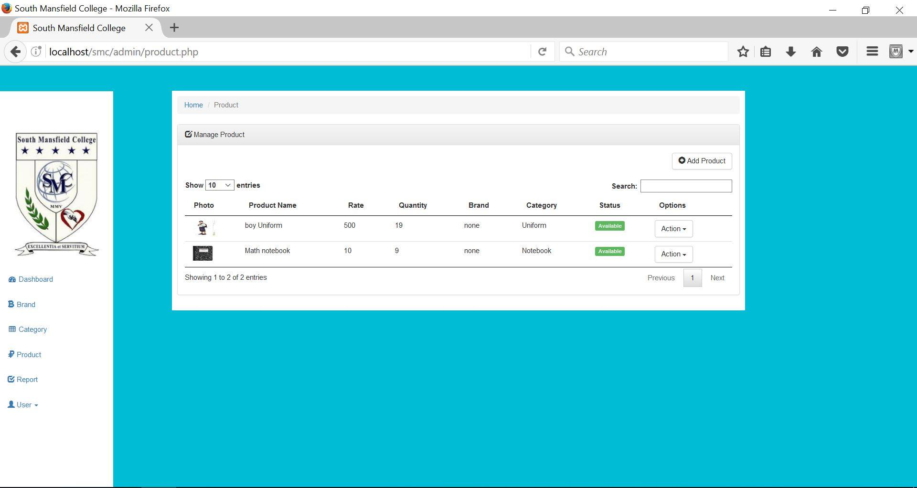

**Management of Orders  
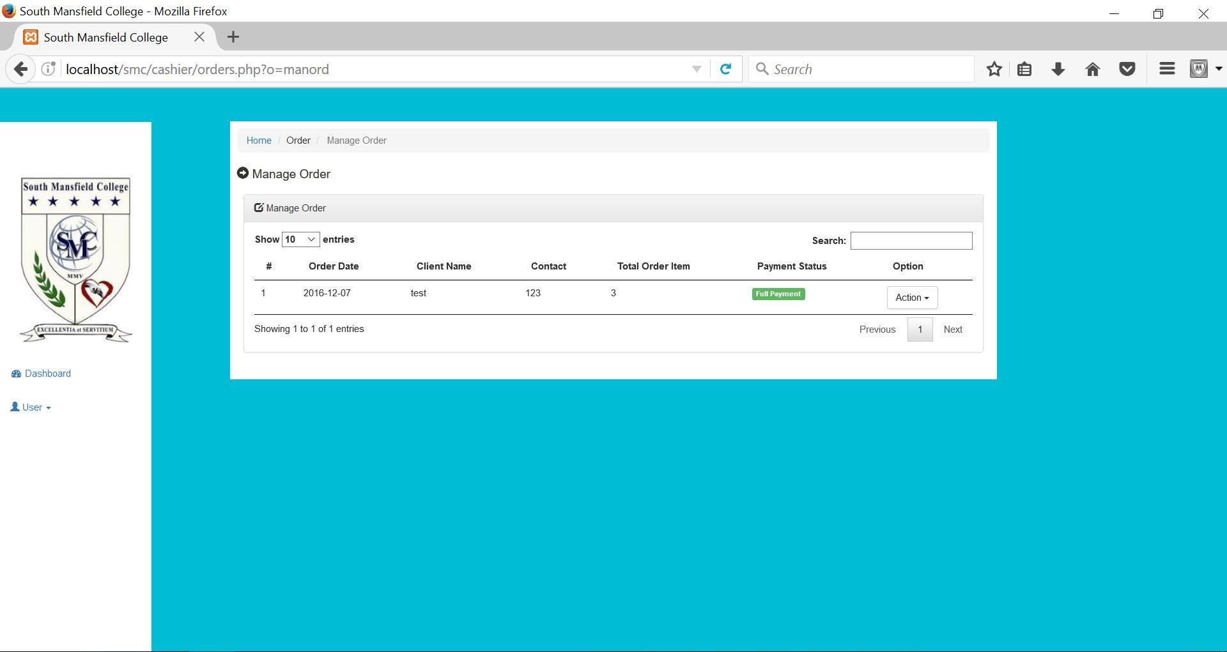**

**Adding of Orders**

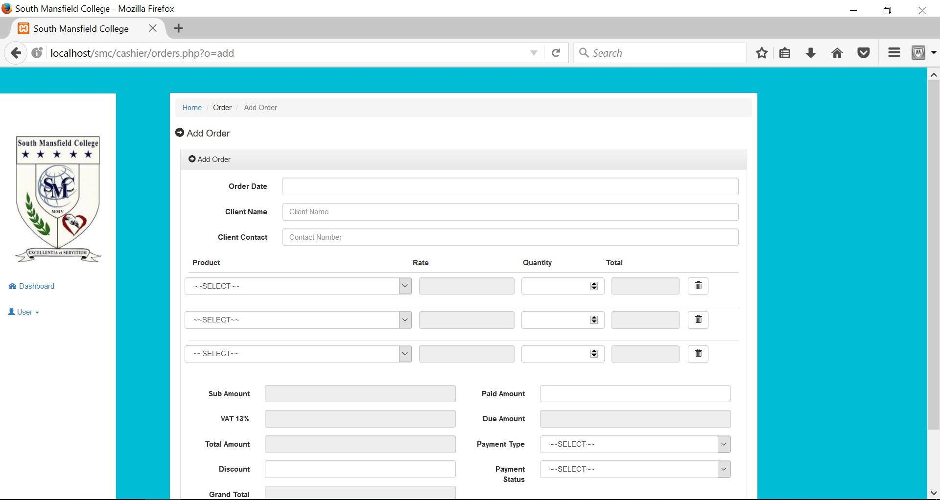

# Conclusions and Recommendations

After we defended our project, the panelist gave us ideas what to improve and what ways can we do it. The first one is to add students database where the user could just easily input their student id number whenever they are creating orders. Also the database should be consisted with the system so that it would be easier to determine the relationships of it. The panelist also stated that whenever the data is deleted, they should be in a table where the deleted items could be recycled since it is a Inventory System, the assets are critical.

They also told us that if the school has a website, we could use that then we will add modules to the website where they can create orders online and will be sent to the backend side. The panelist also mentioned that we could also use intra-net whithin the school premises, where they are kiosk or terminals scattered around the school for students to create their orders.

The documents should also be updated accordingly so it will not be confusing for the client and also for the panelists. Overall, we found out that ideas of the panelist where absolutely great and will improve our system.